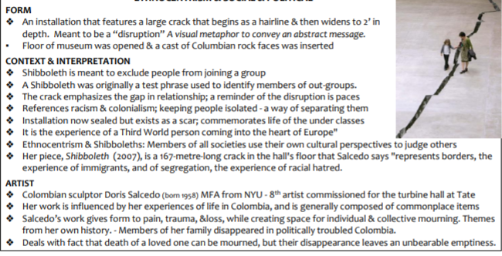

**FORM**

An installation that features a large crack that begins as a hairline & then widens to 2' in

**depth. Meant to be a "disruption" A visual metaphor to convey an abstract message. • Floor of museum was opened & a cast of Columbian rock faces was inserted CONTEXT & INTERPRETATION**

Shibboleth is meant to exclude people from joining a group A Shibboleth was originally a test phrase used to identify members of out-groups. The crack emphasizes the gap in relationship, a reminder of the disruption is paces

References racism & colonialism; keeping people isolated - a way of separating them • Installation now sealed but exists as a scar, commemorates life of the under classes • It is the experience of a Third World person coming into the heart of Europe" • Ethnocentrism & Shibboleths: Members of all societies use their own cultural perspectives to judge others

Shibboleth (2007), is a 167-metre-long crack in the hall's floor that Salcedo says "represents borders, the experience of immigrants, and of segregation, the experience of racial hatred. ARTIST • Colombian sculptor Doris Salcedo (born 1958) MFA from NYU - gth artist commissioned for the turbine hall at Tate • Her work is influenced by her experiences of life in Colombia, and is generally composed of commonplace items • Salcedo's work gives form to pain, trauma, &loss, while creating space for individual & collective mourning. Themes

from her own history. - Members of her family disappeared in politically troubled Colombia. • Deals with fact that death of a loved one can be mourned, but their disappearance leaves an unbearable emptiness.